Shabbos Stories For
parshas pekudei 5785
Volume 16, Issue 26 22 Adar 5785/March 22, 2025
Printed L’illuy nishmas Nechama bas R’ Noach, a”h
For a free subscription, please forward your request to keren18@juno.com
Past emails can be found on the website – ShabbosStories.com

A Forty Year Deadline
By Rabbi Sholom Dov Ber Avzton

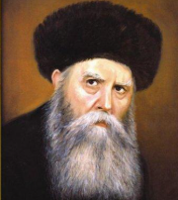
Rabbi Yosef Yitzchak Schneersohn

The Frierdiker Rebbe (Rabbi Yosef Yitzchak Schneersohn, 1880-1950) writes, once when he was on a train, he entered the cafeteria to get some hot water. As he was sitting at the table a Jew who was sitting at a nearby table saw him and for a moment he was in a state of shock. He then came over to him and asked, “Are you by any chance the son or grandson of the Rebbe Maharash of Lubavitch (Rabbi Shmuel Schneersohn)?”
“ I am his grandson,” was the reply.
The person went back to his table sat in deep thought for a few moments and then called over the waiter. He paid the bill without touching anymore of his meal, and walked out the car. Early the following morning, the conductor knocked on my door and told me that a person is asking if he could come in as he would like to speak to me. I replied, presently I am occupied, however, in two hours I will be available, if that works out for him.
The person came back at the designated time, and on his face, it was noticeable that he was extremely agitated and didn’t have a restful night. Through his sobs he related to me his story.
His father was a close chossid of my grandfather, the Rebbe Maharash, and when I was fifteen, he took me to Lubavitch. In the Yechidus the Rebbe told me some points and it left an impact on me that caused me to stop hanging around my non-religious and non-Jewish friends. However, at the end of the school year, while the family was in our vacation house I rejoined them and slowly began forsaking my heritage and the ways of my chassidic upbringing.
A few years later, when I entered university, I had a major argument with my father and moved out toprove that I am no longer under their control or supervision, and broke all connections with my past. I began living a completely nonobservant lifestyle. This pained my parents greatly, but I was determined to demonstrate that I am on my own, even if they would withhold all financial support.
I then joined the young progressives of the Zionist movement, and we tried to help the Jews of Russia, by speaking to certain noblemen in stopping or at least alleviating the governments harsh decrees on the Jews of Russia.
In my mid-twenties we found out certain information that we knew would be important for your holy grandfather to know about, as it would help him in his communal work on behalf of all Jews. I with another individual were given the responsibility to inform him of this development.
From that meeting onwards I developed a relationship with him, as he trusted me to carry out on his behalf highly important and confidential matters regarding these issues of helping our brethren.
In one of our meetings, he suddenly switched topics and asked me when was the last time I put on Tefillin? To demonstrate that I can’t hide anything from me, he then related to me in precise detail what I have done noting the time and place I continued spiraling down in my observance, since our first meeting when I was fifteen years old.
He then looked at me and stated, there is a limit for how long a neshoma could wander aimlessly. Perhaps you do so for thirty or perhaps forty years, but it's going to have to find its place. His words found their mark, and although when I married, I was no longer observant in anything, I resolved to return to my roots. I secretly put on Tefillin and told my wife that I wasn’t hungry when she served a meal. But after a week, I had to tell her the truth and we kashered the kitchen.
One afternoon I was shocked when I saw my father coming to my house, which was in a different city from where he lived, which means he came by train. We have not spoken to each other in many years and I could not figure out why he is coming to speak to me. I realized that it must be something of extreme importance, and I was slightly nervous as to what that could be.
I rushed to greet him, and he told me that he had received a letter from the Rebbe, in which the Rebbe noted that regards should be given over to me. He added. I asked him couldn't you have sent that message with someone else, such as with one of your workers.
My father replied, when the Rebber gives us a mission we are honored to do it ourselves. While we were talking a chossid came over and recited the brocha of She’hechiyunu. My father asked him what is the meaning of this brocha?
He replied its expression of my sheer happiness of finally, after so many years, seeing you two together. He then informed my father that the butcher had recently told him that it's over a half year since I - your son buys all his meat from him. He then also implored my father to participate in the meal that was prepared. At that point my father agreed to accept my invitation and sat down for the meal.
But after your holy grandfather passed on, my observance once again began slipping until it ceased to exist. Last week I went with a group of friends and indulged ourselves in the pleasures of the world, and now I am returning to my house. This week is forty years since I heard those words from your grandfather, and seeing you reminded me of what your holy grandfather told me then and after seeing you [who looks identical to your holy grandfather] I decided I must return to my roots. He then borrowed my tefillin and davened.
Indeed, this time his repentance was completely sincere and he remained very observant for the remainder of his life.
Thinking over the story I asked myself, where was the father happier? Was it when his son was eating in his house or when he felt comfortable to eat in his son's house?
My conclusion was that after feeling for so many years that he cannot eat in his son's house and now seeing that the Rebbe has a special relationship with his son, one that he who is very close to the Rebbe doesn’t have, must have given the father the thrill of his life!
Similarly, when Hashem created the world, the shechina was present in this world. However, when His creations -mankind - made him uncomfortable in this world by their actions, that demonstrated that they are no longer listening to Him, which caused him to distant Himself from them.

Reprinted from the Parshat Ki Sisa 5785 email of Rabbi Avtzon’s Weekly Story.

The Live-Saving Painter
By Rabbi YY Jacobson



Elyasaf Mariah is a kind and humble man, a painter living in southern Israel. His story, which he shared with me, continues to inspire me each day.
For years, the relentless barrage of rockets from Gaza had left the residents of southern Israel with mere seconds—five, ten, twenty, at most thirty—to seek cover. In response to this ever-present threat, Israel constructed miguniyot—standalone, steel-reinforced bomb shelters—on nearly every street corner in the south, designed to withstand artillery fire.
Now, picture a young mother and her children huddled inside one of these shelters as rockets rained down around them. Though these structures offered physical protection, their stark, gray concrete exteriors only added to the sense of fear and isolation.
Enter Elyasaf, the painter. With his palette and brushes in hand, he began transforming these shelters—both inside and out. A flock of birds in flight. The brilliance of a sunrise. A splash of vibrant color. A child’s laughter immortalized in paint. A graceful animal. A majestic mountain. A breathtaking landscape.
With each stroke, he infused these lifelines with warmth and serenity, reminding the trembling Jews within that beyond these walls, there was still beauty in the world. And he was meticulous—each shelter bore a unique painting, giving it a distinct identity and character. The community cherished him, grateful for his kindness and sensitivity. And that was that—until the horrors of October 7th.
Sirens blared. Thousands of rockets rained down upon Israel. Civilians fled to the nearest miguniyot, desperate for safety. At the Nova Music Festival, thousands of young Jews ran in all directions, searching for shelter. Moments later, the unthinkable became reality—terrorists had infiltrated Israel in a brutal massacre, a modern-day pogrom.
Huddled together inside these bomb shelters, panicked civilians began making frantic calls. “Please, come save us. We are inside a migunit, a bomb shelter.”
"Where are you? Which shelter?" came the desperate replies. But how could anyone find them? With hundreds of identical shelters scattered across the region, locating a single one was like searching for a needle in a haystack.
The trapped civilians didn’t have an address. The only thing they could describe was the artwork—the images painted on the walls of their shelter.
The next morning, Elyasaf’s phone erupted with calls and messages from frantic family members. The only clue we have is a painting, they told him. Our loved ones sent us pictures—a butterfly with two small boys chasing it, a girl in a green dress holding a white balloon.
Call after call described one of Elyasaf’s murals. But he knew exactly where each shelter was, because he remembered every painting he had created. Shelter by shelter, he guided families and rescue teams to their precise locations, helping save countless lives.
We often fail to recognize the true impact of our work. Had you asked Elyasaf on October 6, 2023, “What do you do for a living?” He likely would have answered, “I’m just a simple painter. Nothing dramatic.”
But he wouldn’t have realized the significance of what he had been doing. He would think that he is merely adding color to concrete walls. In reality, though, he had unknowingly created a life-saving system—a network of markers that, on one of the darkest days in Jewish history, became beacons of help and hope.
Because wherever we are and whatever we do is guided by Divine Providence. And when we give our whole heart to our work—planting seeds of goodness, kindness, and love—we can never fully grasp the magnitude of what we are accomplishing.
Consider this.
Had the police contacted the Chief of Staff of the IDF, the Israeli Minister of Defense, the head of Mossad, the head of Shin Bet, or even the Prime Minister himself, not a single one of them would have been able to locate those shelters. There was only one person in all of Israel who could—Elyasaf Mariah.
The Talmud teaches: "Each person must say, ‘For my sake, the world was created’” (Sanhedrin 37a). We often struggle to believe this. Really? For me, the entire world was created?
But Elyasaf’s story proves it so. There was something only he could accomplish—something no one else in Israel, or even the world, could have done.
We often see ourselves as ordinary people, simply trying to make it through life. But this is a shallow perspective.
Judaism teaches that G-d tells each of us, “I need you. No matter where you are, what you do, your emotional state, or your circumstances—your presence in this world is purposeful. You are here to save lives, to lift hearts, and to bring light into the darkness.”
Like Elyasaf, you have something to offer that no one else can. And G-d is waiting for you to paint your picture and to illuminate the world with your unique light.

Reprinted from the Parashat Tetzaveh 5785 edition of TorahAnytimes.com Newsletter.

The Special Brachah
Given to a Jewish Mother

A story took place with Rav Meir Arik, zt”l, about the perfect Emunah of a Jewish mother. It was at a time when many of the young men were being forcefully drafted into the army. They would all go straight to Rav Meir for his Brachah, to see if that would help them avoid the draft.
Those who went to him knew right away what their fate would be, because Rav Meir had a system in place. If he gave the Bachur the Sefer Machaneh Yisroel, which was a Sefer that was written by the Chofetz Chiam teaching the main Halachos that apply to soldiers in the army, the Bachur knew that he would be drafted.
However, if Rav Meir said to them, “Whoever accepts on himself the yoke of Torah, the yoke of the government and the yoke of worldly concerns are removed from him,” then he knew that his freedom was guaranteed. This took place in Vienna, the capital of Austria, three months after Hitler, ym”sh, had risen to power.
A woman came to see Rav Meir Arik. She was crying because the authorities had taken her son, who was her only child. She didn’t know where they had moved him to, and it had already been two weeks since she last saw him, and she didn’t know what she should do.
Rav Meir said to her, “Whoever accepts on himself the yoke of Torah, the yoke of the government and the yoke of worldly concerns are removed from him.” He then asked her, “If your son is found, do you promise to get him involved in only learning Torah?”
Without hesitating she replied, “Yes. Rebbe, I agree to this, and I promise.” Rav Meir said, “If so, then I give him a Brachah that he be Zocheh to become a Talmid Chacham that toils only in Torah. Now go and search for him. You have accepted for him and Bentched him to merit the yoke of Torah. You will surely find him now.”

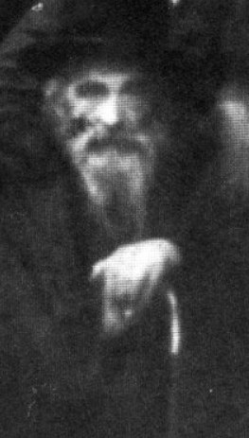
Rabbi Meir Arik

The woman left his house, and after just one hour, she returned to him a second time, together with her son! He asked her how this happened, and she explained that immediately after she left the Rav’s house, she didn’t even think twice. She acted with the Emunah Peshutah of a Jewish woman who heard the words right from the mouth of the Rav, and she turned straight to Hashem, and asked Him for help with a piercing Tefilah that came from a broken heart.
With this Emunah, she went to the jail that was nearest to her, walked inside and simply said, “Give me my son!” The officer that was there just looked at her and said incredulously, “What?” For a moment, she became very nervous, but she strengthened her resolve and shouted again, “Give me my son!”
After this second cry, the officer’s demeanor changed, and he asked her, “What is his name?” She told him, and he asked her to wait a little. He went into a back room, and a short while later, he came back with him and said, “Here is your son.”
The woman then managed to send her son to Eretz Yisroel, where he entered one of the Yeshivos, and was involved with learning Torah constantly. Because of this, he was also saved from the terrible destruction of six million Jews by the Nazis, ym”sh, and the Brachos of the mother and the Tzadik Rav Meir Arik were entirely fulfilled!

Reprinted from the Parshas Ki Sisa 5785 email of Rabbi Yehuda Winzelberg’s Torah U’Tefilah.

Five Words that Made a Major Change for the Better

Rav A. L. Scheinbaum shared a story about someone who took the initiative to do something when he saw a need, and not just to feel bad about it. He writes that the person involved in this story has outstanding humility, and did not permit his name or the city he currently lived in to be mentioned.
In 1991, a man from New York who looked for opportunities to do Chesed and had a heart of gold, single-handedly established a Chesed organization, which goes by the name of She’aris HaPlate, or Edible Leftovers, Inc.
Attending a wedding, he noticed the caterers packing up the food after the Chupah. Being inquisitive by nature, he asked, “What are you doing with all of that food?”
The caterer replied, “Why? Do you want it?”
It was five words, and that was all. But it was those five words, however, that motivated this man to establish a unique food Gemach. He took the food home, where he repackaged it, and discreetly dropped it off at the homes of people that he knew were in need of food.
Soon, he had set up an entire network of volunteers. They would accumulate the food from Simchah halls throughout the New York area, and then, often elegantly, would repackage the food to give to those whose families that could use it. Sometimes they would deliver it to those who were making a Simchah, but could not afford all of the food. The leftovers from a Simchah could supply about thirty families with a beautiful meal.
This man shared a letter that the organization received from a Chassan who was an orphan, and who was the beneficiary of a lavish Kiddush from this wonderful Gemach. He wrote, “I did not have to feel like an orphan at my own Aufruf. I was able to have a Kiddush, a reception fit for a prince, just like my friends’ parents make for them!”

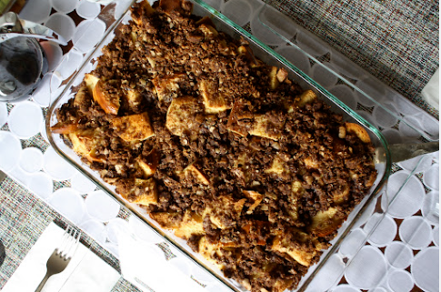

A short while ago, a mother who was distraught called the Gemach. She had a large family which consisted of seventy-five people, and that upcoming Shabbos was her son’s Bar Mitzvah. However, she had no way to provide the food for the Simchah, because she simply had no money. She asked if there was any way the Gemach could help.
The Gemach came through. They provided the woman with delicious meals, as well as flower arrangements collected from a wedding hall the previous night. Edible Leftovers Inc. collects food and flowers from approximately three hundred Simchos each year.
In addition, they collect the food after Pesach from New York area hotels and five hotels in Florida. The inspiration of one man, together with the dedication of many volunteers, brings this all together. It is the result of a few people going beyond talking about something and feeling bad about something, and actually getting up and doing something to help a situation!

Reprinted from the Parshas Ki Sisa 5785 email of Rabbi Yehuda Winzelberg’s Torah U’Tefilah.
The Grand Rabbi

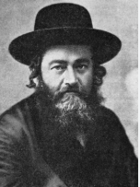
Rabbi Meir Shapiro

In order to be accepted in Yeshivas Chachmei Lublin, one had to pass a test on 200 blatt Gemara. This was no easy task — for mid-teen bachurim to know 200 blatt Gemara, with Rashi and Tosafos thoroughly. Young Shmuel, though, was determined. He wanted to attend that yeshiva at whatever price it cost. His family tried persuading him that Yeshivas Chachmei Lublin wasn’t for him, but nothing stood before him. He was determined.
At the yeshiva’s entrance exam, they told him that he didn’t know the material needed to pass. Not only did he not know 200 blatt, but even a simple reading of the Gemara was challenging for him. When they asked him why he was testing if he wasn’t up to par, he told them that he wanted to join the yeshiva and learn there so that one day he’d be able to be tested on that amount. Still, he was rejected.
When he got to the train station to go home, he pulled onto the platform as the train was pulling out. When he approached the ticket counter, he was told that the coming train would only leave in three hours’ time. “You can find yourself a comfortable bench in the meantime,” he was told.
Instead, Shmuel returned to the yeshiva to learn until the scheduled time. Sitting in the yeshiva, Reb Meir Shapiro, the Rosh Yeshiva of Yeshivas Chachmei Lublin, noticed him and his hasmada, saying that if he was returning to learn for such a short duration of time, then he was accepted to the yeshiva. Reb Meir would talk the hanhalah into reconsidering their decision, but he can be sure about getting accepted.
There was just one problem: How was he going to keep up? He would be worlds apart from the other bachurim. To help him, the mashgiach, Reb Shimon of Zelichov, known by many as Reb Shimme’le, saw to it that bachurim would learn with Shmuel throughout the day. That way, over time, he’d be brought up to par with the rest of the yeshiva. He had one-hour chavrusos throughout the day.
Still, after several months of diligent learning, the hanhalah once again reviewed Shmuel’s situation and concluded that remaining in yeshiva was unfruitful for Shmuel and that, for his sake, he should transfer yeshivos. While he was stepping down the concrete steps to leave, he heard a voice coming from behind him. It was the mashgiach. “Where are you going?” asked Reb Shimme’le. Shmuel responded that the hanhalah had decided he should leave.
This stirred the mashgiach, who went right back into the yeshiva and called together all the members of the hanhalah. Reb Shimme’le asserted that Shmuel needed to remain in the yeshiva, and that there were no two ways about it. The hanhalah members began trying to reason with him, explaining why they felt another yeshiva would be more beneficial for him, but Reb Shimme’le rebutted their claims.
“I accept full responsibility on this masmid,” he stated. “I’ll see to it that he gets even better care moving forward.” Hearing the mashgiach’s adamance melted all their hearts to let Shmuel remain. Reb Shimme’le set out on his mission to get Shmuel better chavrusos and to oversee his shteiging up-close.
All this continued until one year, Parshas Zachor. In the yeshiva’s dining room, they displayed a large poster listing the names of all the yeshiva boys. Next to the name was a “title” that (they felt!) was what the bachur was destined to become. Many boys were given titles as rabbis of cities in Poland, while others got positions as roshei yeshiva. The best boy was “identified” as “Rav of Lodz,” after the gaon, Rav Eliyahu Chaim Meisel. (At the young age of 19, Reb Eliyahu Chaim had been appointed as the Rav of Lodz.
When he had been nifter, no one had been able to fill his shoes. His position had been divided into seven parts, each part given to another Rav. This was the “position” given to the best bachur in the yeshiva.)
Shmuel scanned the sheet, only to find his name at the very bottom. The last line read: “Shmuel Ha’Levi — an erlicher shoemaker.” When Shmuel saw this, he was beside himself. “This is what I get after all the hasmada I’ve put in?” Was he putting in days and nights of hasmadah, only to become a shoemaker? Getting that position wasn’t very encouraging.
He ran to his room to release his bottled-up tears. After some time, he left his room, but he still carried a ton of bricks in his heart. This continued until one day, he said to himself:
“What will this self-pity benefit me? It’s not going to make me the Rav of Lodz, right? Not even into a Purim Rav? Let me return to the Gemara. Only that way will I hit some position one day.” He mustered up the courage and continued engrossing himself in his learning. Over the next few months, whenever writing a chiddush in his notebook, he signed off his name as: “Shmuel Ha’levi — Ava”d (the rav of) Lodz.” (These notes are around till today.)
Signing off those sheets that way gave him the resolution and energy to keep going. He kept going, and eventually he started to see the fruits of his labor. He started sharing his fruit with the others around him, and they all enjoyed the sweetness he offered. Shmuel continued pushing, until the day he became the world-renowned posek, Rav Shmuel Wosner, whose brilliance enlightened all those around — far beyond Lodz.
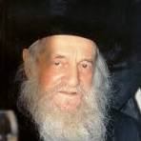

Rav Shmuel Wosner

He sweetened the mouths of Klal Yisrael who eagerly drank his sagely advice. There are several takeaways from this story. One is that he didn’t give up despite all the rejections he faced. He overpowered his family’s resolution in dismissing him from attending that yeshiva. He persisted after being rejected by the hanhala. He overcame the denunciation he faced from his friends. Despite all that – actually better said, because of all that — he succeeded and became the prestigious gaon who he became. The other takeaway is how he pumped himself when he faced those contaminations. He gave himself that positive name, and that gave him the vigor to keep going. It was worthwhile.

Reprinted from the Parshas Ki Sisa 5785 email of Rabbi Moshe Hirschberg’s Zichru Toras Moshe.
Gan Eden is Mine
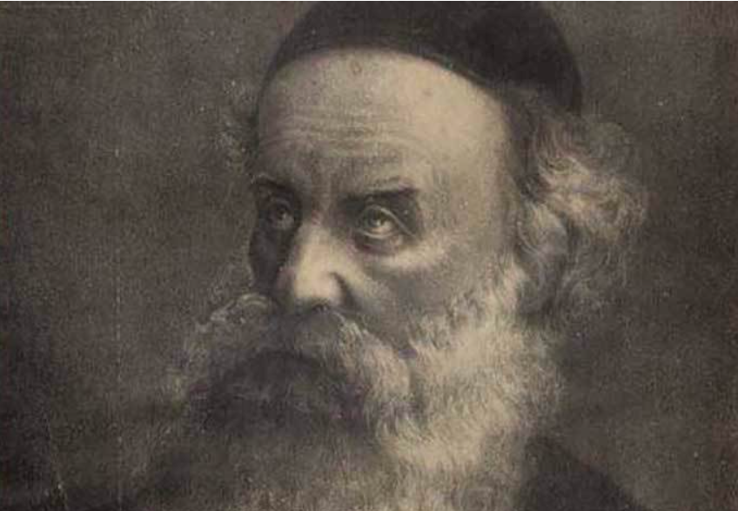
The Baal HaTanya (Rabbi Shneur Zalman of Liadi.)

The Baal HaTanya’s grandson, Reb Nachum, wore a luxurious jacket with fur around the collar, which didn’t find liking by the Baal HaTanya. He bought it around the time he got married, and the Baal HaTanya told him that he didn’t want him to wear it.
His grandson answered that he couldn’t stop wearing it..
The Baal HaTanya said, “I’ll buy you another jacket.”
His grandson repeated that he couldn’t change the jacket. “I will give you the money to replace it,” the Baal HaTanya pleaded, but still he refused. He couldn’t part from his coat.
Finally, the Baal HaTanya told him, “If you take off this coat, I guarantee you a portion with me in Gan Eden.”
This time, the grandson accepted the offer. It was too good to refuse.
People asked the Baal HaTanya how he could guarantee this great reward for his grandson. Perhaps he won’t deserve it!
The Baal HaTanya replied, “You saw how hard it was for him to remove the coat. It wasn’t just the coat, and it wasn’t just the style. He had a burning yetzer hara preventing him from agreeing to my offers. I understood that it was a great test for him, and if he passed the test, then he deserves to be brought to such a place in Gan Eden for that alone.” (Torah Wellsprings, Toldos, p. 5)

Reprinted from the Parshas Ki Sisa 5785 email of Rabbi Moshe Hirschberg’s Zichru Toras Moshe.
A List that Judy Would
Never Compromise on
By Rabbi David Ashear

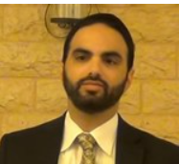

Judy* was an older single in her forties. As the years marched on, her hopes of marrying were dwindling – but she refused to give up. Along with strengthening her tefillos, she decided she needed to become more open to shidduch suggestions. Until then, she had clung fast to a list of requirements on which she would never compromise.
Number one, the man could not have an accent; number two, he could not be divorced (and surely not have children!); and number three, he could not be someone who wanted his wife to cover her hair, as that was something she could not see herself doing.
Recently, it occurred to Judy that perhaps Hashem really did have someone for her, but she was not allowing herself to meet him because of “the list.” Judy put her requirements aside, and she is now happily married to the man she had been waiting for.
She does not feel as if she settled on anything less than the best. Her husband does have an accent – and she loves it. He was divorced, and she understands why it happened. He also has children, and she loves the way he interacts with them.
As for covering her hair, she is doing it happily at her husband’s request. She has learned more about the beauty of that mitzvah, and feels uplifted by it. Judy transformed her life from a bleak and seemingly endless situation and is now happily married to a man who doesn't fit any of the criteria she initially had on her checklist. (Excerpted from the ArtScroll book – “Living Emunah on Shidduchim”)

Reprinted from the Parshas Ki Sisa 5785 email of The Weekly Vort.

